**How to Javascript : Assignment 3**

Assignment 1: Change Background Color

change-background-color-assignment.html:

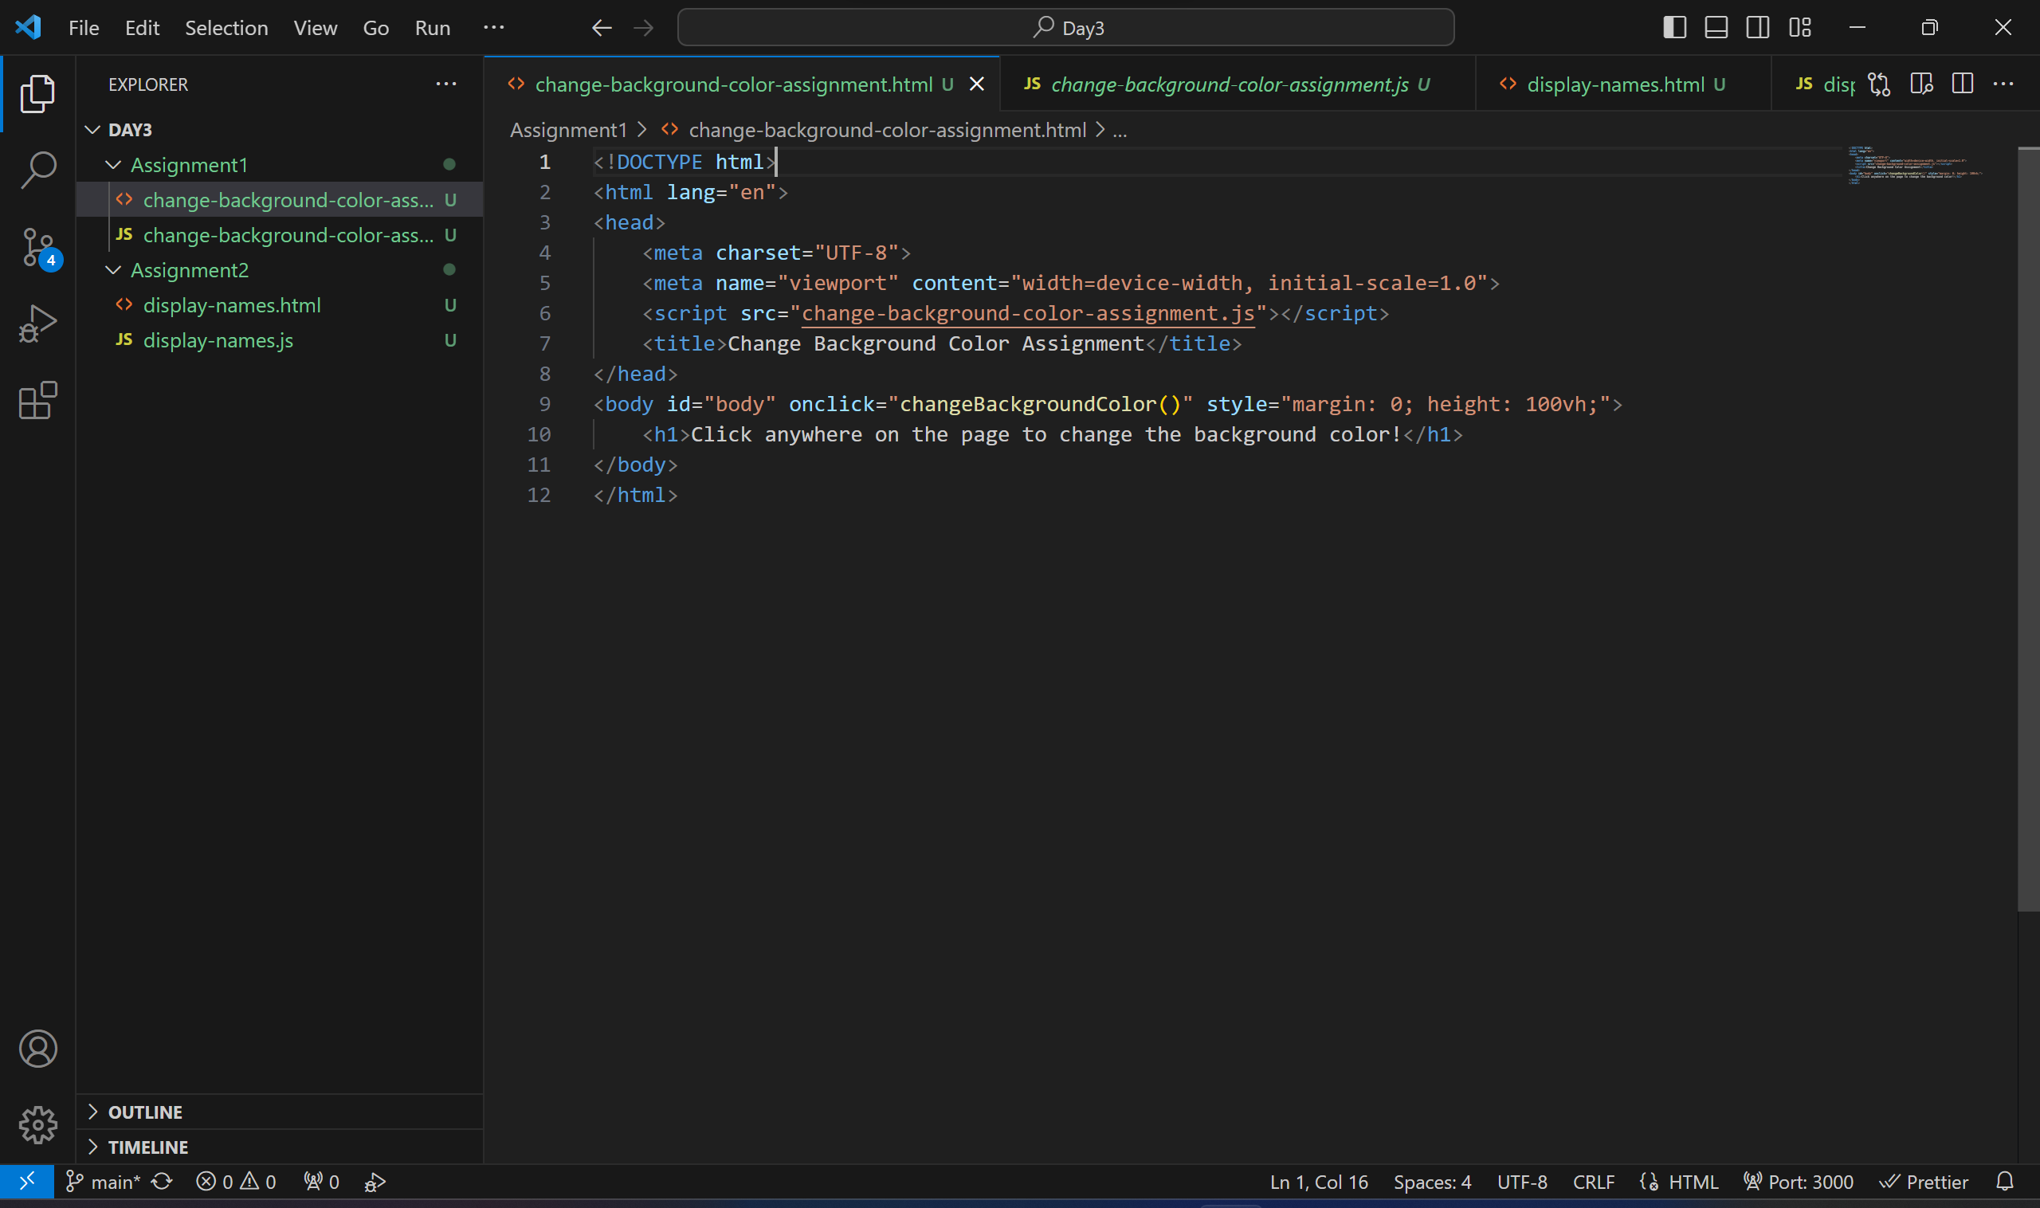

change-background-color-assignment.js:

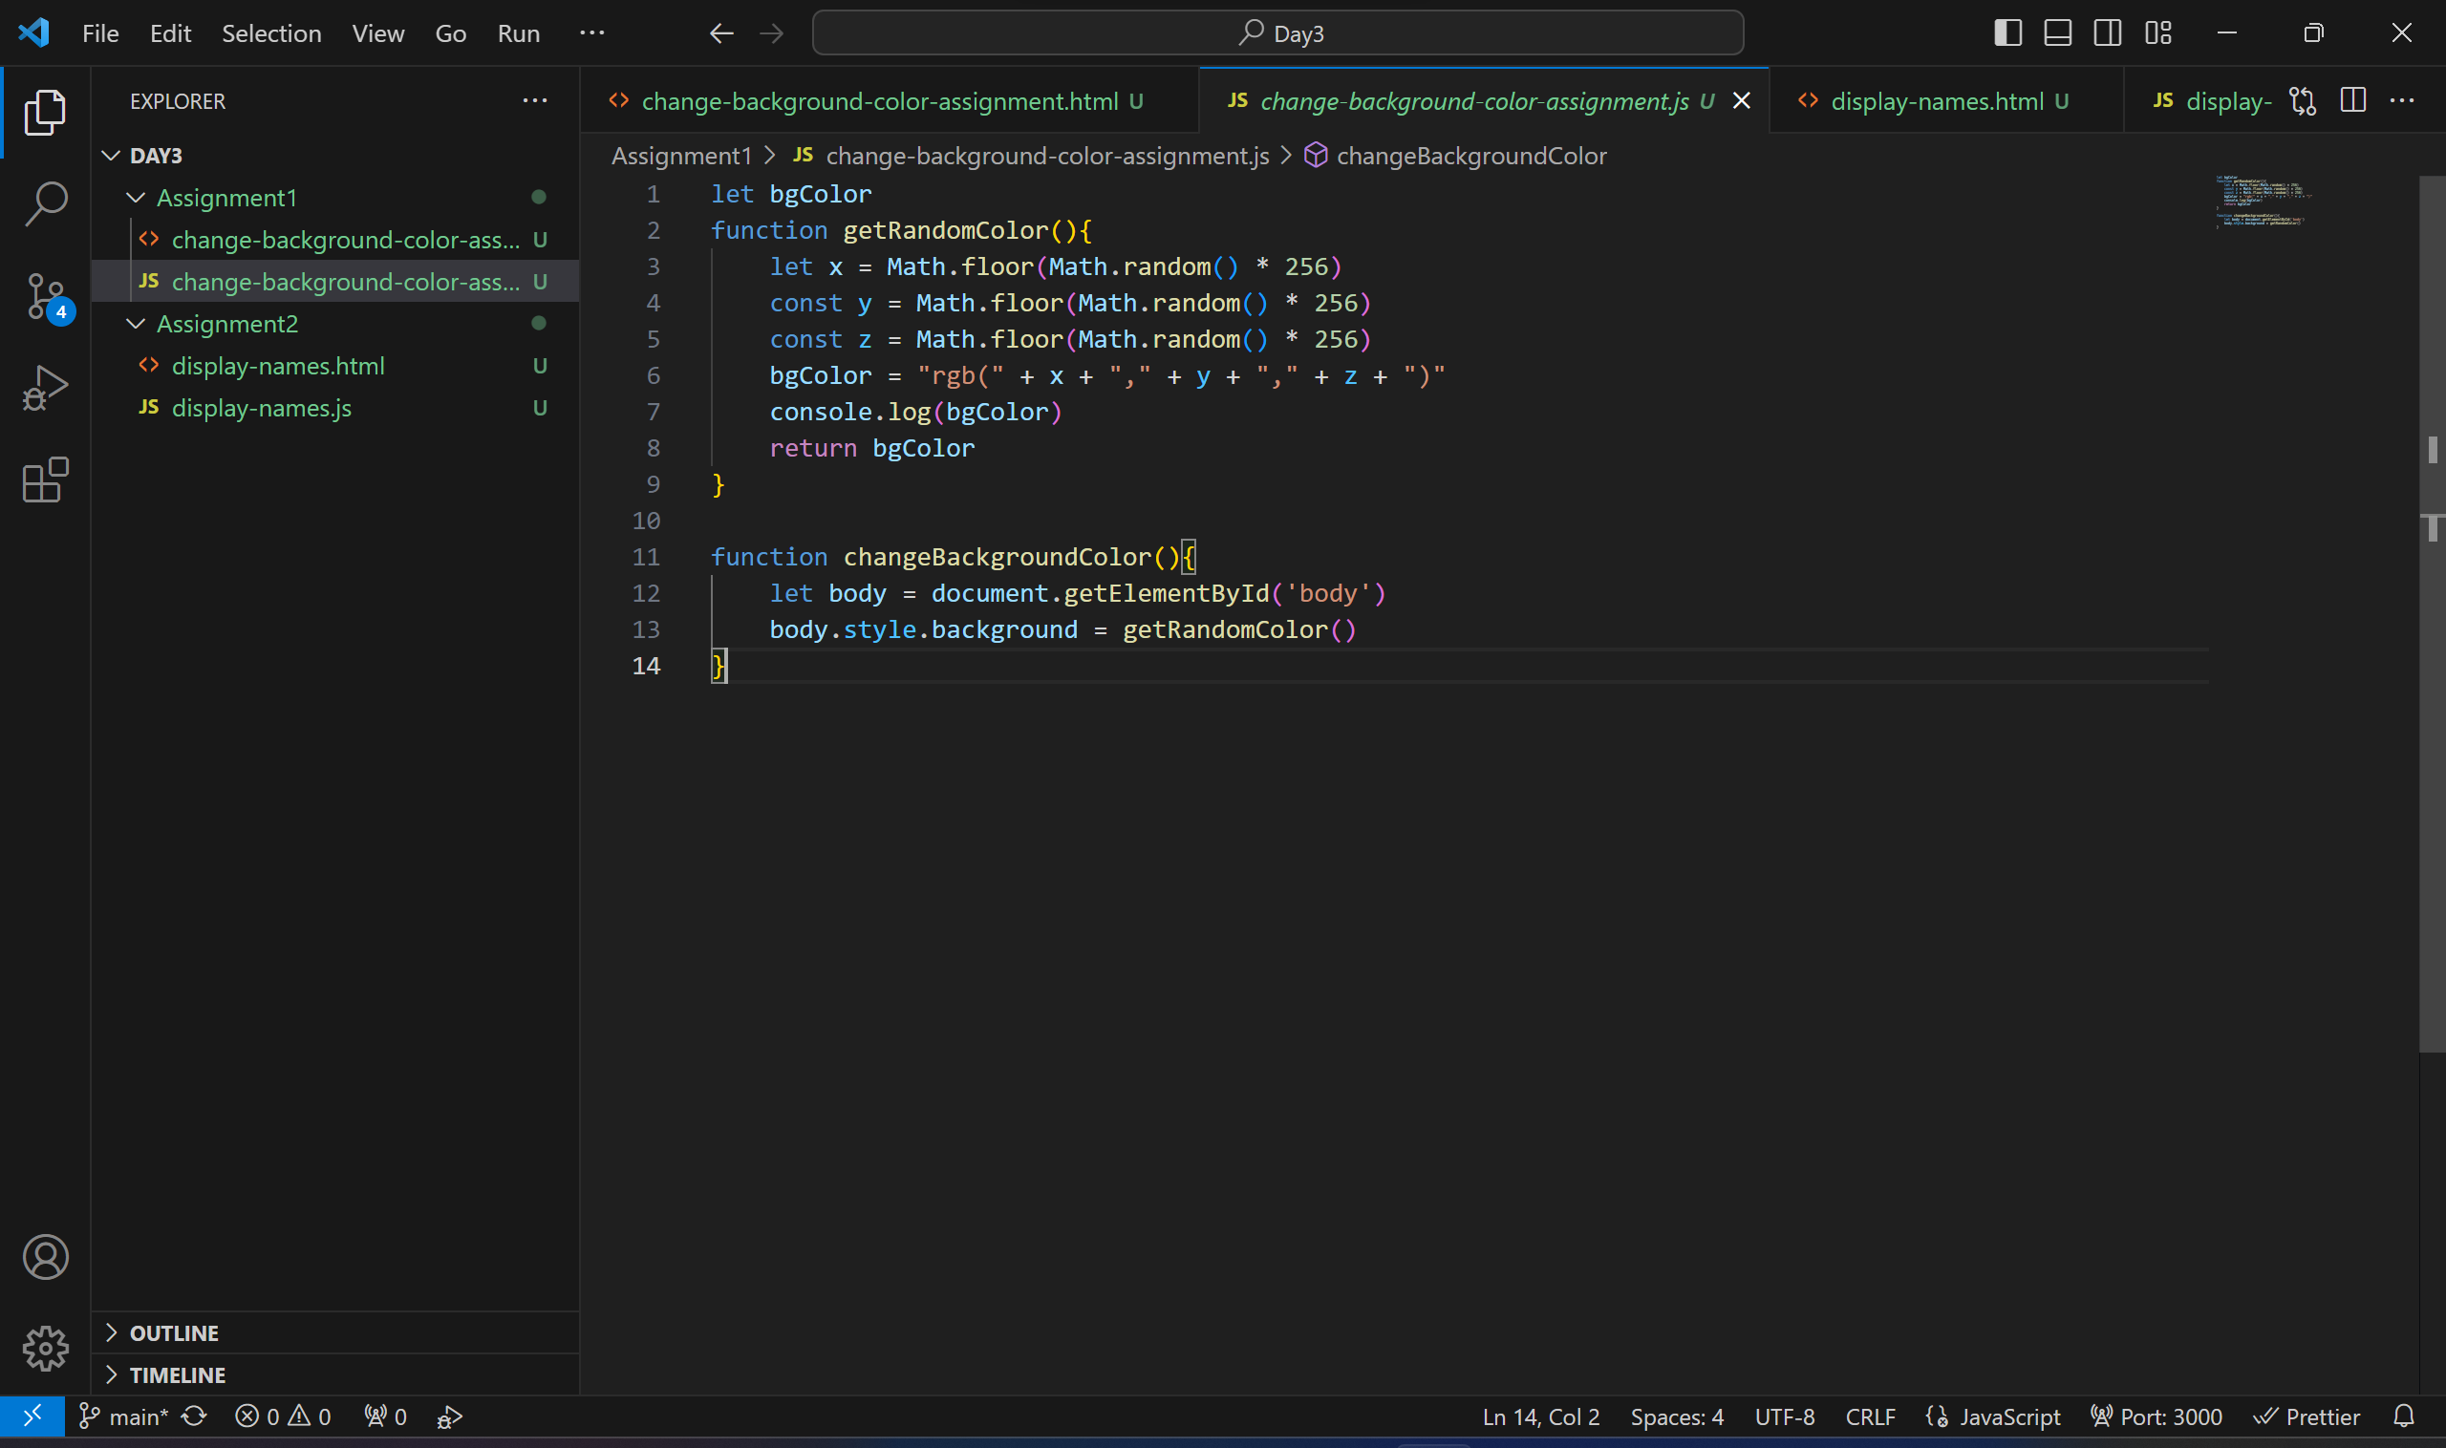

**Assignment 2: Display names**

display-names.html

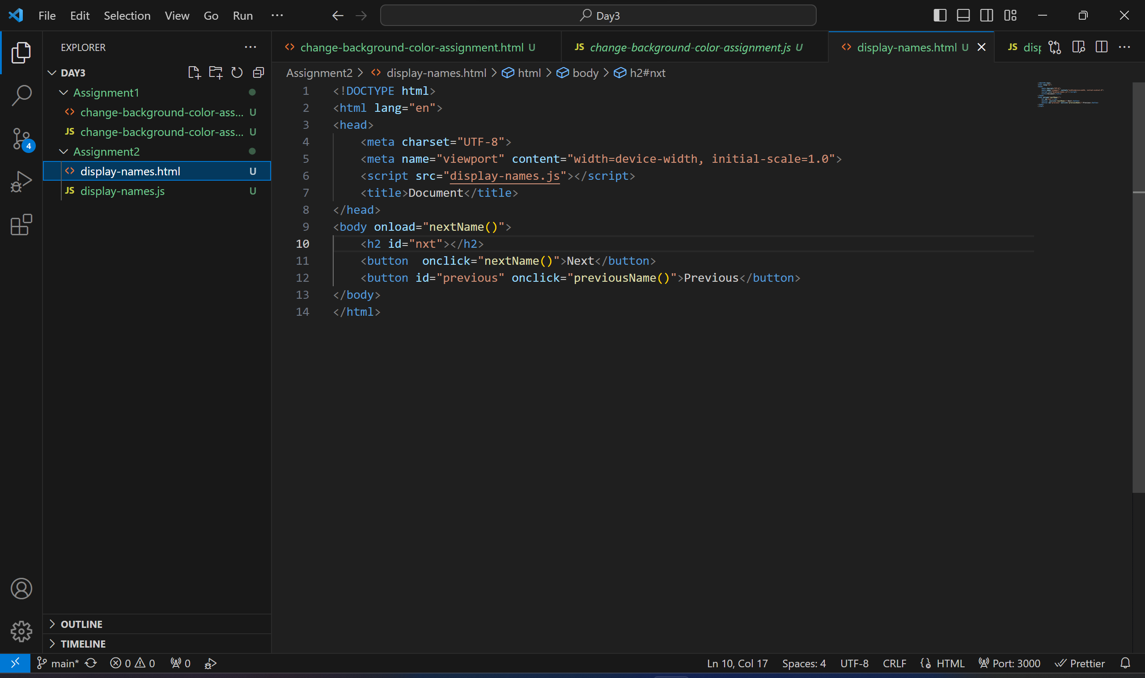

display-names.js: